Instructions:

1. Unzip the file.
2. Run index.html.
3. Data files folder has data files. We can use them to load the data.

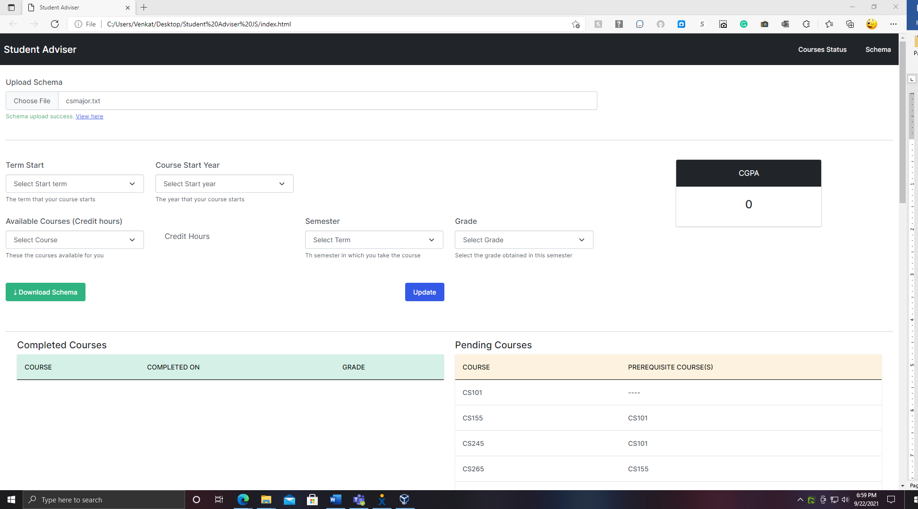

View here link would present data on the left-hand side of window.

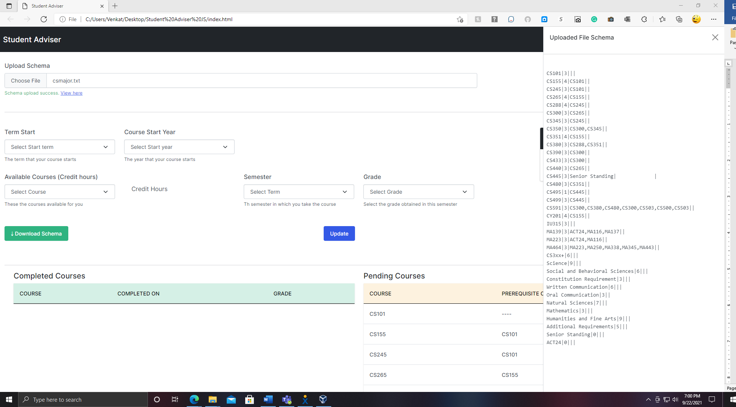

Select Term start and Course Start year dropdowns so that Semester dropdown for available options.

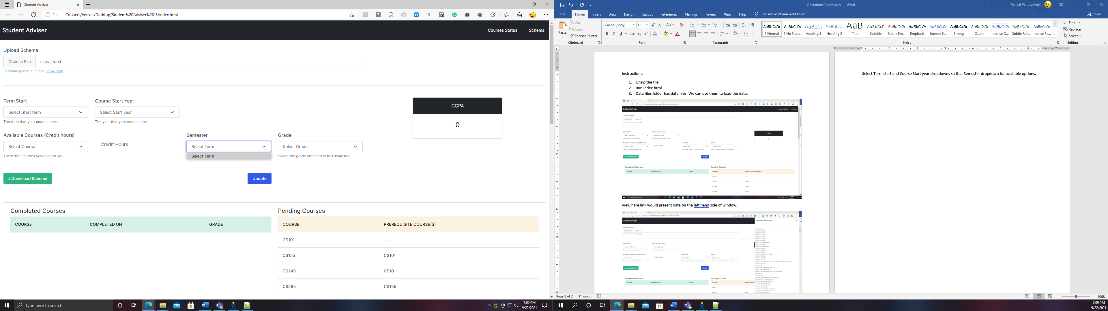

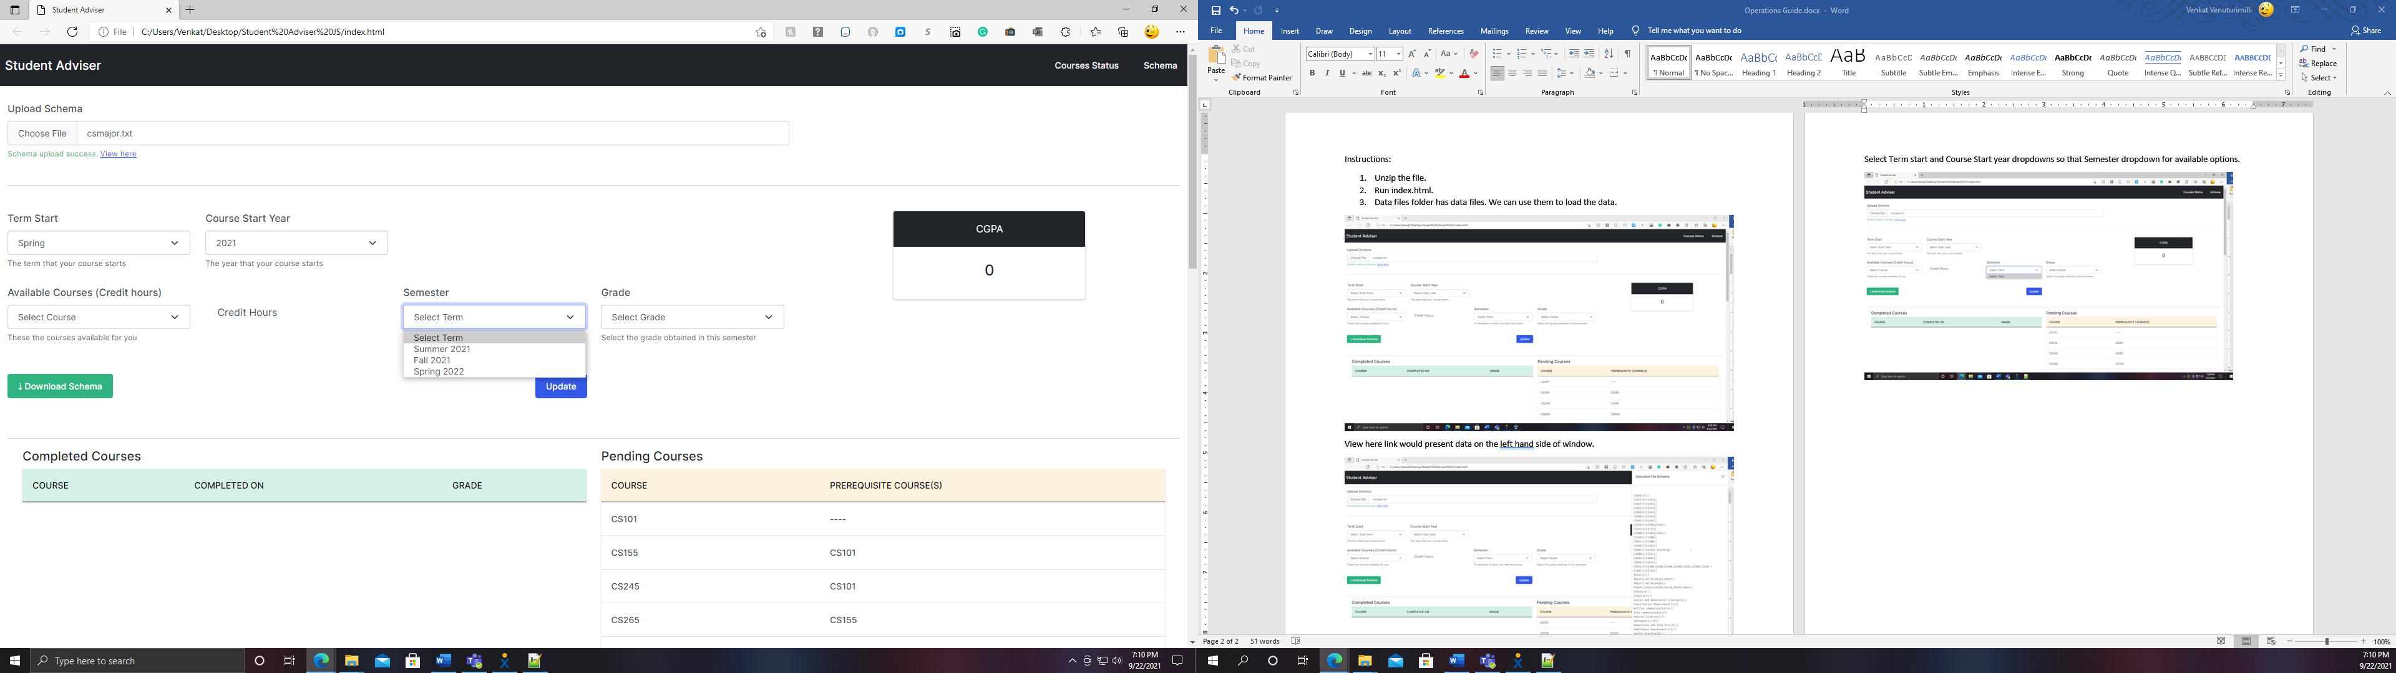

GPA would automatically calculated once Update button is clicked.